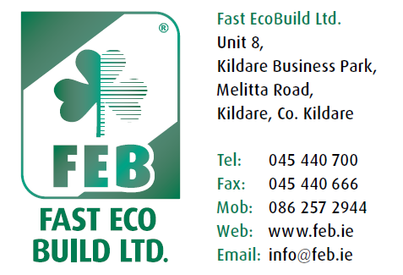

FAST EcoBuild Ltd

Dear Customer,

Thank you for choosing FAST External Insulated Render System to insulate your home.

Please read the enclosed details of the System & familiarize yourself with the cleaning & fixing details.

If you require any further information please do not hesitate to contact our company for advice.

Kieran Carew
General Manager
086-2572944.

Unit 8
Kildare Business Park
Melitta Road
Kildare Co. Kildare
045-440700

